CSE / CI 351 | Java Lab
COURSE OBJECTIVES:
1. To teach fundamentals of object oriented programming in Java. Understand various concepts of JAVA.
2. To familiarize Java environment to create, debug and run simple Java programs.
3. To demonstrate java compiler and eclipse platform and learn how to use Net Beans IDE to create Java Application.
Programs:
- Write a Java program that prompts the user for an integer and then prints out all prime numbers up to that integer. (use Scanner class to read input)
Program:
import java.util.Scanner;
class primenumbers
{
public static void main(String[] args)
{
int n;
int p;
Scanner s=new Scanner(System.in);
System.out.println("Enter a number: ");
n=s.nextInt();
System.out.println("prime numbers are: ");
for(int i=2;i<n;i++)
{
p=0;
for(int j=2;j<i;j++)
{
if(i%j==0)
p=1;
}
if(p==0)
System.out.println(i);
}
}
}
Output:
C:\Users\hp1>d:
D:\>cd javaprograms
D:\javaprograms>javac primenumbers.java
D:\javaprograms>java primenumbers
Enter a number:
50
prime numbers are:
2
3
5
7
11
13
17
19
23
29
31
37
41
43
47
D:\javaprograms>
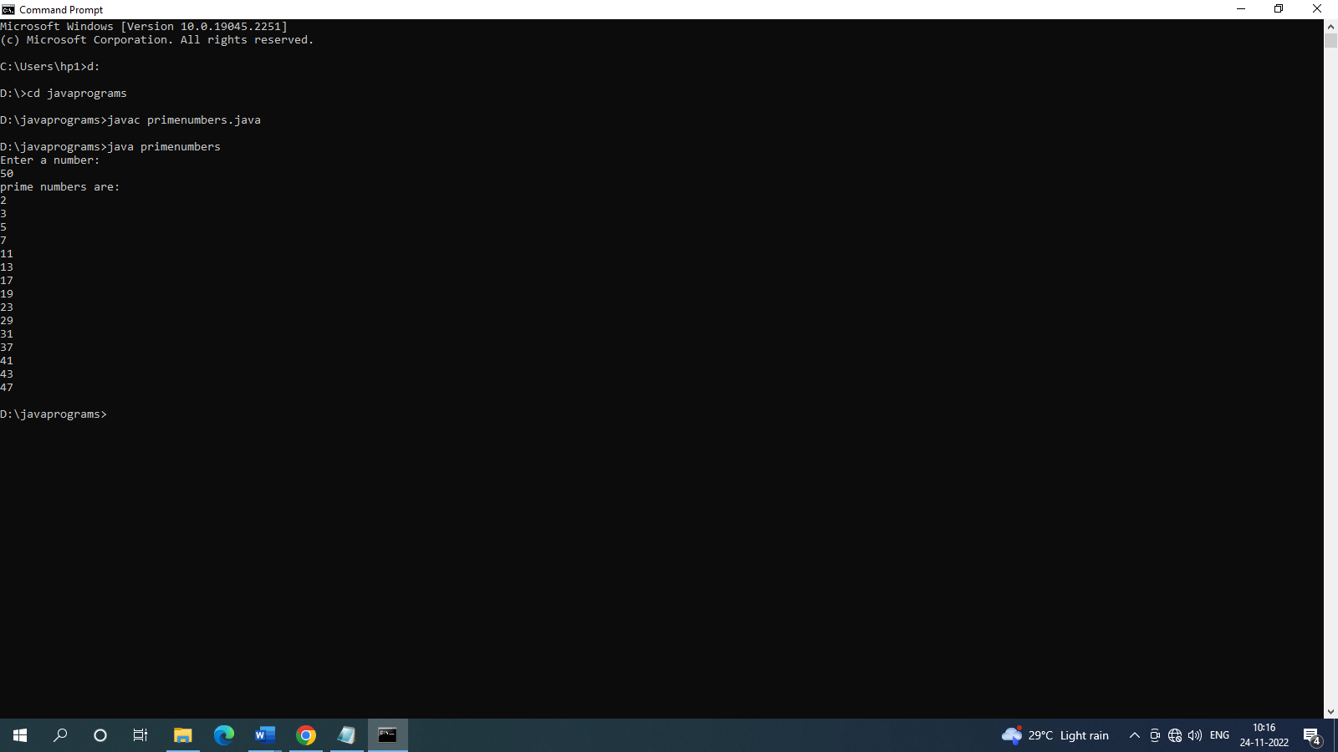

- Write a Java program that uses both recursive and non recursive functions to print the nth value in the Fibonacci sequence.
Non recursive
import java.util.*;
public class FibonacciSeries
{
public static void main(String args[])
{
int nterms, first = 0, second = 1, current, i;

Scanner in = new Scanner(System.in);
System.out.println("Enter number of terms in Fibonacci Series");
nterms = in.nextInt();

for(i = 0; i < nterms; i++)
{
if(i < 2)
{
current = i;
}
else
{
current = first+ second;
first=second;
second=current;
}
System.out.print(current + " ");
}
}
}

D:\javaprograms>javac FibonacciSeries.java

D:\javaprograms>java FibonacciSeries
Enter number of terms in Fibonacci Series
9
0 1 1 2 3 5 8 13 21

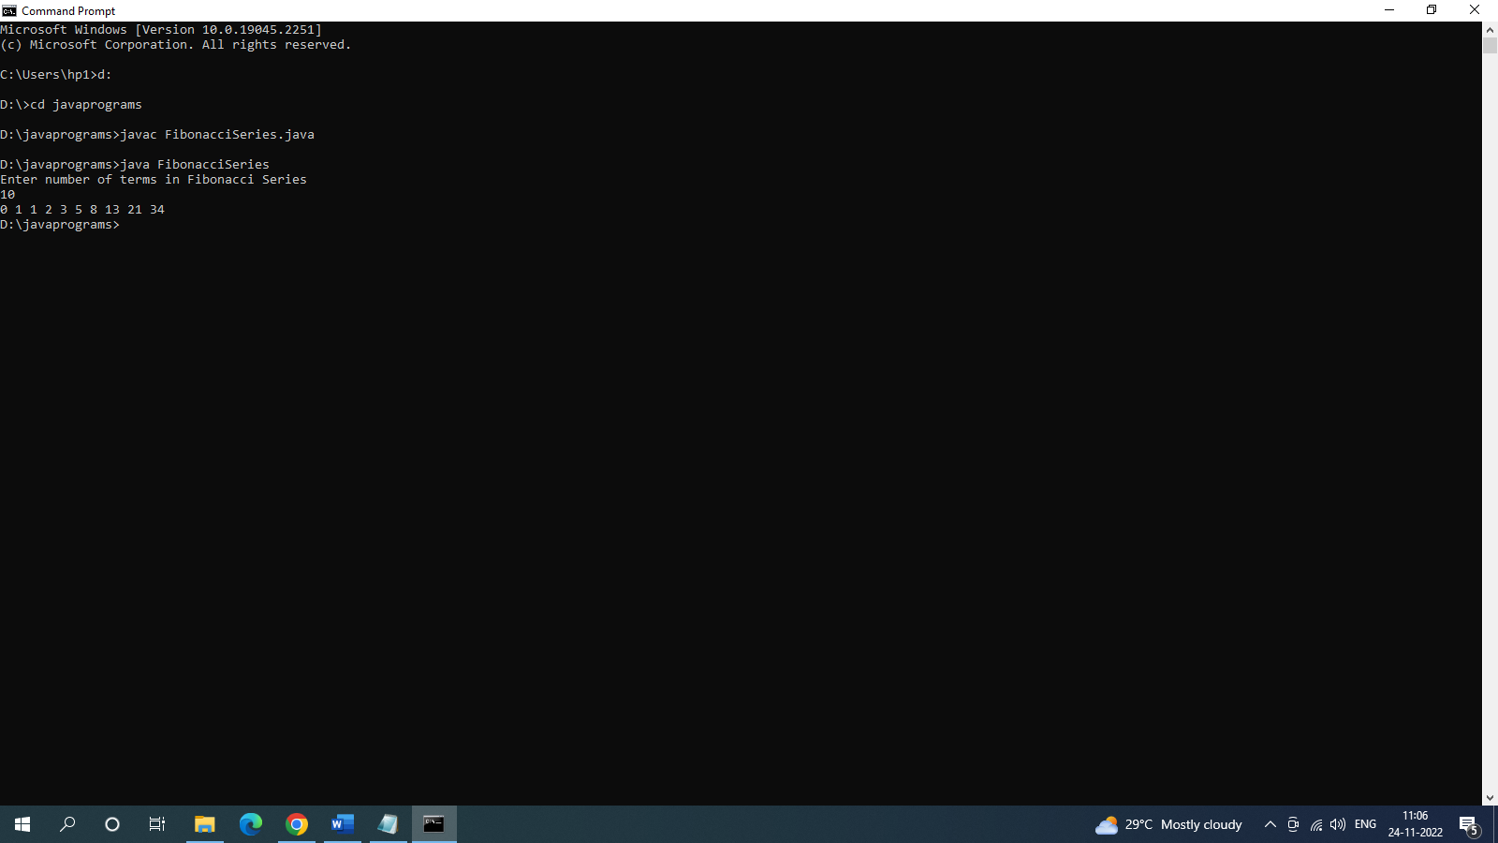

Recursive:
import java.util.*;
public class FibonacciSeriesRecursion
{
public static void main(String args[])
{
int terms, i;
Scanner in = new Scanner(System.in);
System.out.println("Enter number of terms in Fibonacci Series");
terms = in.nextInt();
for(i = 0; i < terms; i++)
{
System.out.print(fibonacci(i) + " ");
}
}

public static int fibonacci(int num)
{
if(num < 2)
return num;
return fibonacci(num - 1) + fibonacci(num - 2);
}
}

C:\Users\hp1>d:
D:\>cd javaprograms
D:\javaprograms>javac FibonacciSeriesRecursion.java
D:\javaprograms>java FibonacciSeriesRecursion
Enter number of terms in Fibonacci Series
10
0 1 1 2 3 5 8 13 21 34
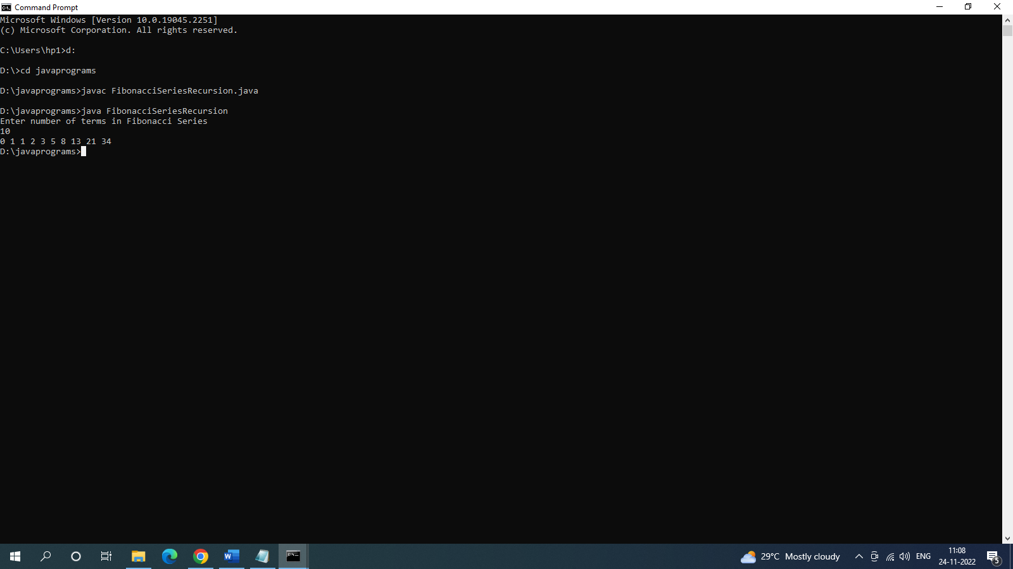

- Write a Java program to multiply two given matrices.
Program:
import java.util.Scanner;
class matrixmul
{
public static void main(String[] args)
{
Scanner s=new Scanner(System.in);
System.out.println("enter n");
int n=s.nextInt();
int i,j,k;
int a[][]=new int[n][n];
int b[][]=new int[n][n];
int c[][]=new int [n][n];
System.out.println("enter a matrix");
for(i=0;i<n;++i)
for(j=0;j<n;++j)
a[i][j]=s.nextInt();
System.out.println("enter b matrix");
for(i=0;i<n;i++)
for(j=0;j<n;++j)
b[i][j]=s.nextInt();
System.out.println("result is");
for(i=0;i<n;++i)
for(j=0;j<n;++j)
{
c[i][j]=0;
for(k=0;k<n;++k)
{
c[i][j]+=a[i][k]*b[k][j];
}
System.out.println(" "+c[i][j]);
}
}
}

Output:
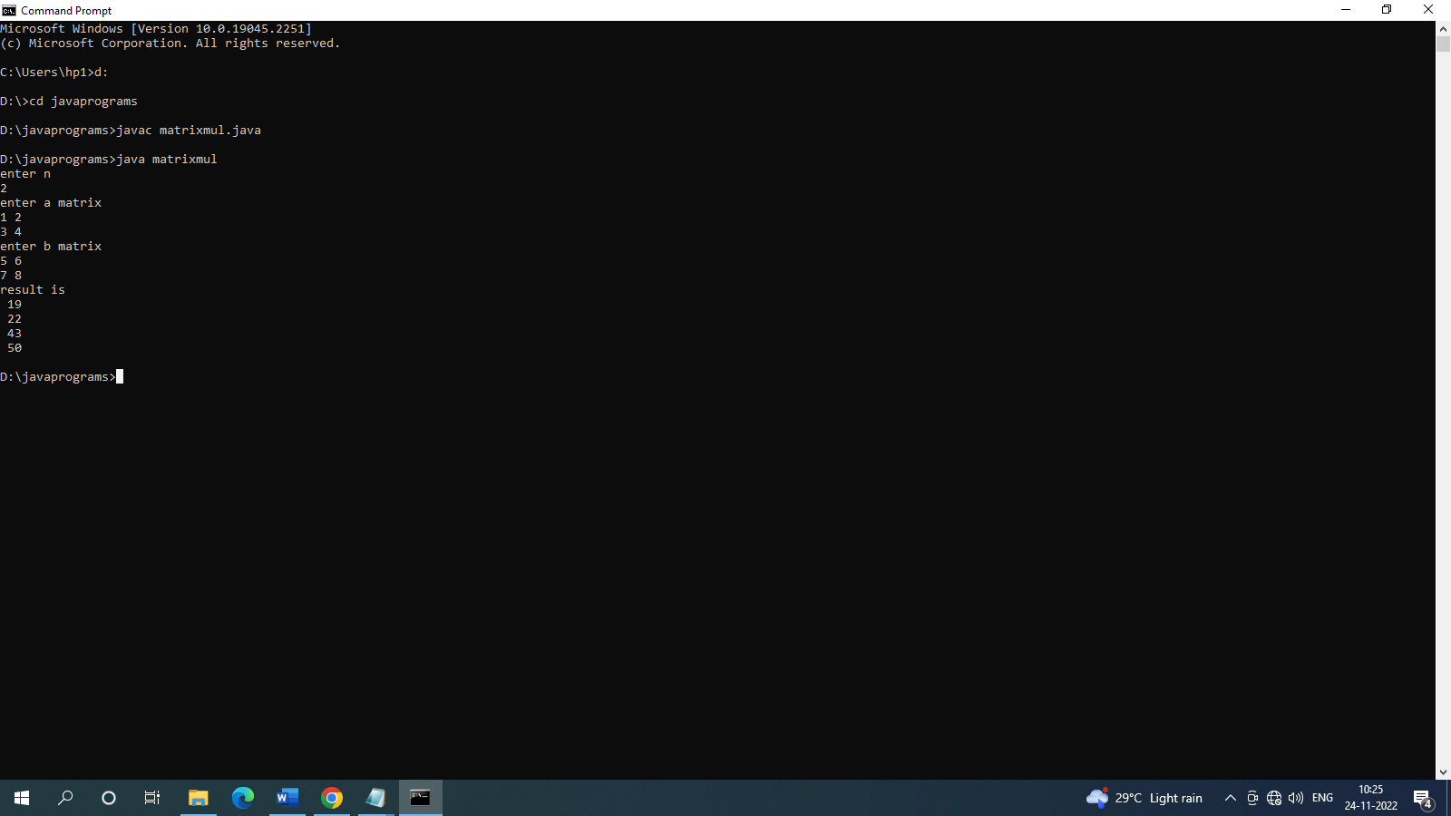
C:\Users\hp1>d:

D:\>cd javaprograms

D:\javaprograms>javac matrixmul.java

D:\javaprograms>java matrixmul
enter n
2
enter a matrix
1 2
3 4
enter b matrix
5 6
7 8
result is
19
22
43
50
D:\javaprograms>

- Write a Java program that checks whether a given string is a palindrome or not.
import java.util.Scanner;
public class Palindrome
{
public static void main(String args[])
{
String a, b = "";
Scanner s = new Scanner(System.in);
System.out.print("Enter the string you want to check:");
a = s.nextLine();
int n = a.length();
for(int i = n - 1; i >= 0; i--)
{
b = b + a.charAt(i);
}
if(a.equalsIgnoreCase(b))
{
System.out.println("The string is palindrome.");
}
else
{
System.out.println("The string is not palindrome.");
}
}
}
C:\Users\hp1>d:

D:\>cd javaprograms

D:\javaprograms>javac Palindrome.java

D:\javaprograms>java Palindrome
Enter the string you want to check:madam
The string is palindrome.
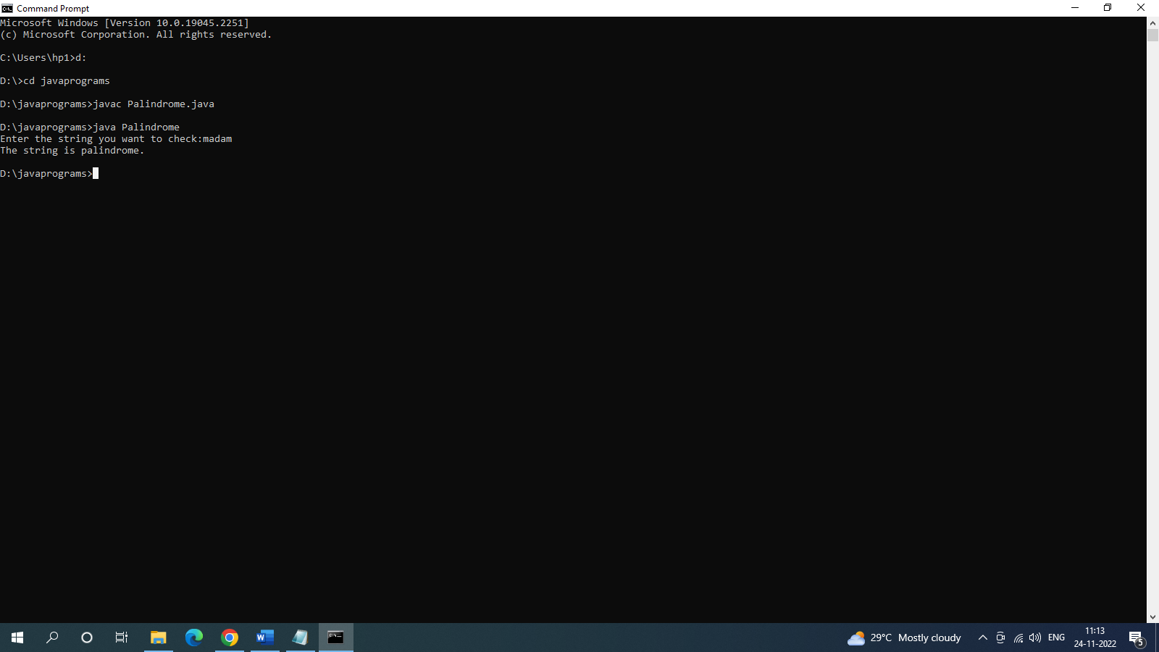
- Write a Java program to create a Student class and find the grade of the student.
import java.util.Scanner;

public class grade
{
public static void main(String args[])
{
int marks[] = new int[6];
int i;
float total=0, avg;
Scanner scanner = new Scanner(System.in);
for(i=0; i<6; i++)
{
System.out.print("Enter Marks of Subject"+(i+1)+":");
marks[i] = scanner.nextInt();
total = total + marks[i];
}
avg = total/6;
System.out.print("The student Grade is: ");
if(avg>=80)
{
System.out.print("A");
}
else if(avg>=60 && avg<80)
{
System.out.print("B");
}
else if(avg>=40 && avg<60)
{
System.out.print("C");
}
else
{
System.out.print("D");
}
}
}

C:\Users\hp1>d:

D:\>cd javaprograms

D:\javaprograms>javac grade.java

D:\javaprograms>java grade
Enter Marks of Subject1:40
Enter Marks of Subject2:80
Enter Marks of Subject3:80
Enter Marks of Subject4:40
Enter Marks of Subject5:60
Enter Marks of Subject6:60
The student Grade is: B

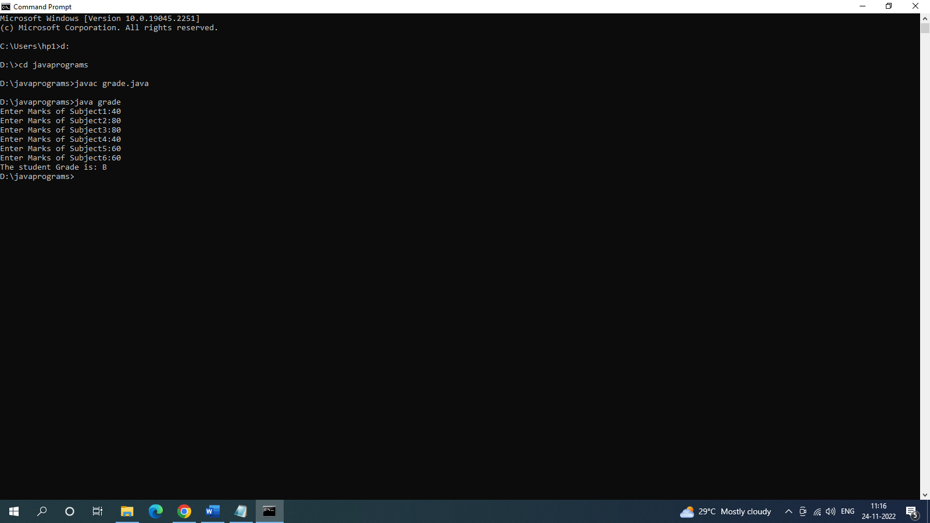
- Write a java program to create an abstract class named Shape contains number Of Sides ( ) method and Trapezoid, Triangle and Hexagon classes extends the class Shape.

import java.util.*;
abstract class Shape
{

abstract int numberOfSides();

}

class Trapezoid extends Shape
{

private static int sides=4;

int numberOfSides()
{

return sides;

}

public String toString()
{

return "Trapezoid";

}

}

class Triangle extends Shape
{
private static int sides=3;

int numberOfSides()
{
return sides;
}

public String toString()
{
return "Triangle";
}

}

class Hexagon extends Shape
{

private static int sides = 6;

int numberOfSides()
{

return sides;

}

public String toString()
{

return "Hexagon";

}

}

public class Shapes
{

public static void main(String args[])
{

Shape[] shapes = new Shape[4];

Trapezoid tp = new Trapezoid();

Triangle tr = new Triangle();

Hexagon hx = new Hexagon();

shapes[0]=tp;

shapes[1]=tr;

shapes[2]=hx;

for(int i=0 ; i<3 ;i++)

{

System.out.println(shapes[i].toString()+" #sides:"+shapes[i].numberOfSides());

}

}

}

D:\javaprograms>javac Shapes.java

D:\javaprograms>java Shapes
Trapezoid #sides:4
Triangle #sides:3
Hexagon #sides:6

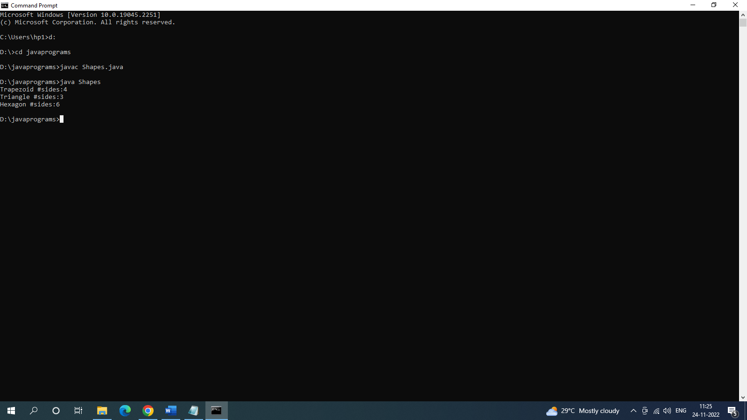
- Write a Java program to read copy content of one file to other by handling all file related exceptions.
public class copyfiles
{
public static void main(String[] args)
{
String sourceFile, destFile, line, content="";
Scanner scan = new Scanner(System.in);

System.out.print("Enter the Name of Source File: ");
sourceFile = scan.nextLine();
try
{
FileReader fr = new FileReader(sourceFile);
BufferedReader br = new BufferedReader(fr);

for(line=br.readLine(); line!=null; line=br.readLine())
content = content + line + "\n";

br.close();

System.out.print("Enter the Name of Destination File: ");
destFile = scan.nextLine();

try
{
FileWriter fw = new FileWriter(destFile);
fw.write(content);
fw.close();
System.out.println("\nFile copied successfully!");
}
catch(IOException ioe)
{
System.out.println("\nSomething went wrong!");
System.out.println("Exception: " +ioe);
}
}
catch(IOException ioe)
{
System.out.println("\nSomething went wrong!");
System.out.print("Exception: " +ioe);
}
}
}
Output:
sourcefile.txt
Hai
Hello
How are you
Welcome to java lab

D:\javaprograms>java copyfiles
Enter the Name of Source File: sourcefile.txt
Enter the Name of Destination File: destfile.txt
File copied successfully!
destfile.txt
Hai
Hello
How are you
Welcome to java lab

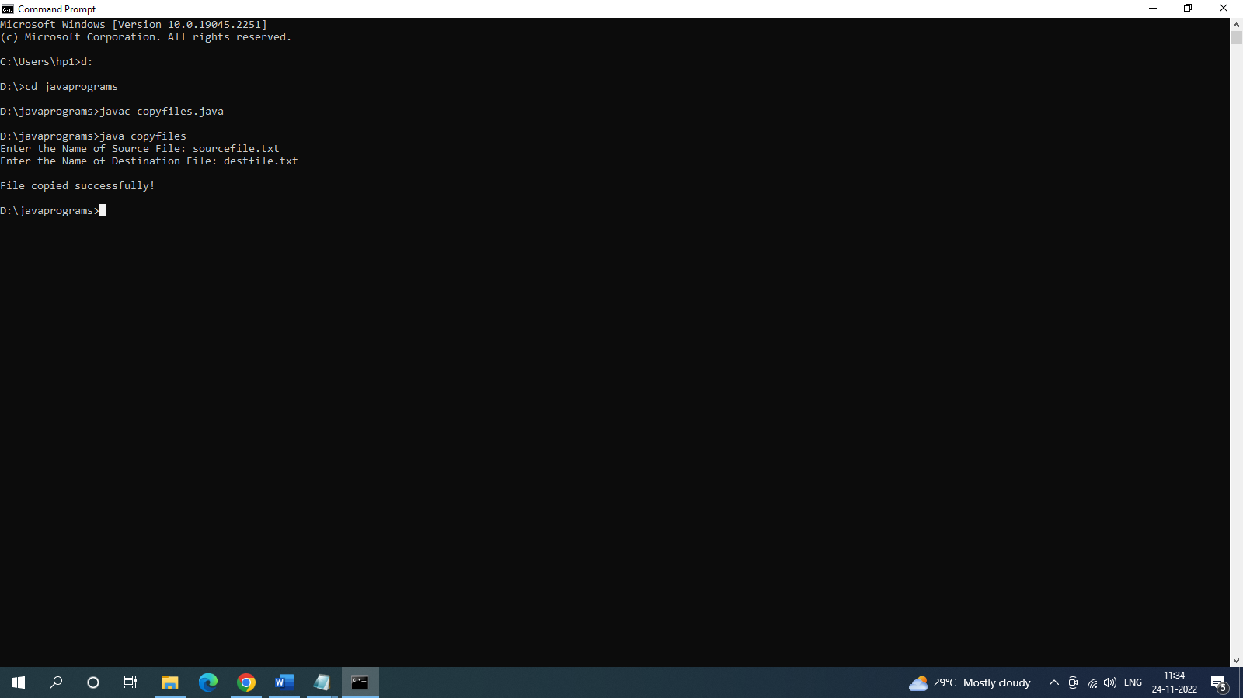
- Write a Java program that reads a file name from the user, and then displays information about whether the file exists, whether the file is readable, whether the file is writable, the type of file and the length of the file in bytes.
import java.io.*;

import java.util.*;

class Fileinfo{

public static void main(String[] args)
{

Scanner input = new Scanner(System.in);

System.out.println("Enter the name of the file:");

String file_name = input.nextLine();

File f = new File(file_name);

if(f.exists())

System.out.println("The file " +file_name+ " exists");

else

System.out.println("The file " +file_name+ " does not exist");

if(f.exists())
{

if(f.canRead())

System.out.println("The file " +file_name+ " is readable");

else

System.out.println("The file " +file_name+ " is not readable");

if(f.canWrite())

System.out.println("The file " +file_name+ " is writeable");

else

System.out.println("The file " +file_name+ " is not writeable");

System.out.println("The file type is: " +file_name.substring(file_name.indexOf('.')+1));

System.out.println("The Length of the file:" +f.length());

}

}

}
C:\Users\hp1>d:

D:\>cd javaprograms

D:\javaprograms>javac Fileinfo.java

D:\javaprograms>java Fileinfo
Enter the name of the file:
copyfiles.java
The file copyfiles.java exists
The file copyfiles.java is readable
The file copyfiles.java is writeable
The file type is: java
The Length of the file:1294
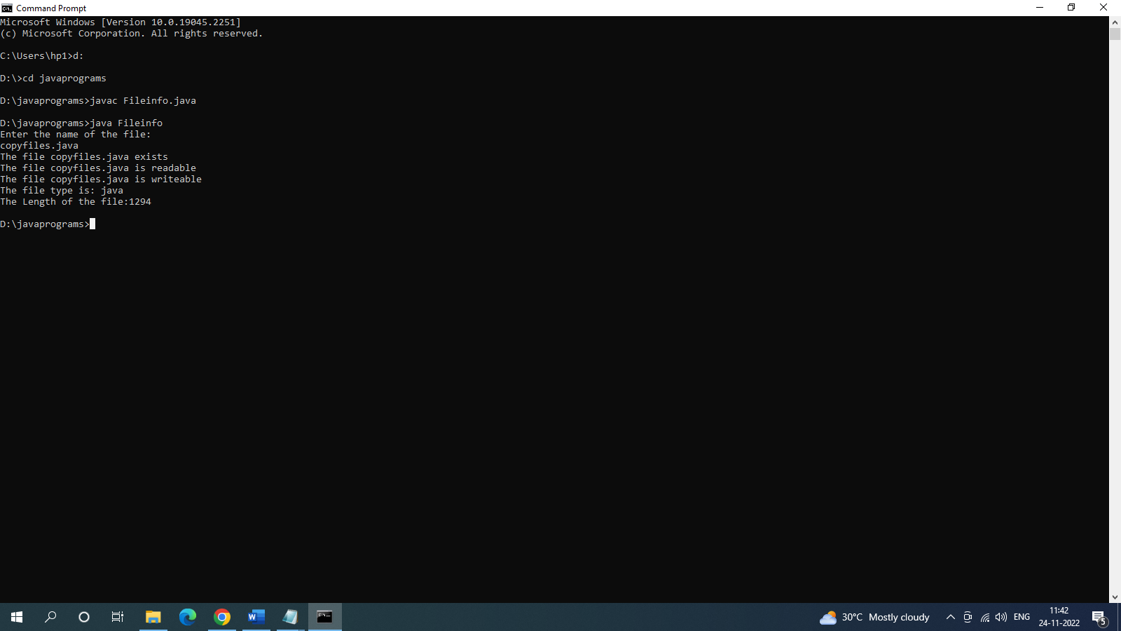

- Write a Java program that reads a file and displays the file on the screen.

import java.util.Scanner;
import java.io.*;

public class FileDisplay
{
public static void main(String[] args)
{
Scanner scan = new Scanner(System.in);

System.out.print("Enter the Name of File: ");
String fileName = scan.nextLine();

String myline = null;
try
{
FileReader fr = new FileReader(fileName);
BufferedReader br = new BufferedReader(fr);

System.out.println("\n----The content of File----");
myline = br.readLine();
while(myline != null)
{
System.out.println(myline);
myline = br.readLine();
}
br.close();
}
catch(IOException ex)
{
System.out.println("\nError occurred");
System.out.println("Exception Name: " +ex);
}
}
}

Output:

C:\Users\CBCLI27>d:

D:\>javac FileDisplay.java

D:\>java FileDisplay
Enter the Name of File: filedis.txt

----The content of File----
Hi
Welcome
how are you

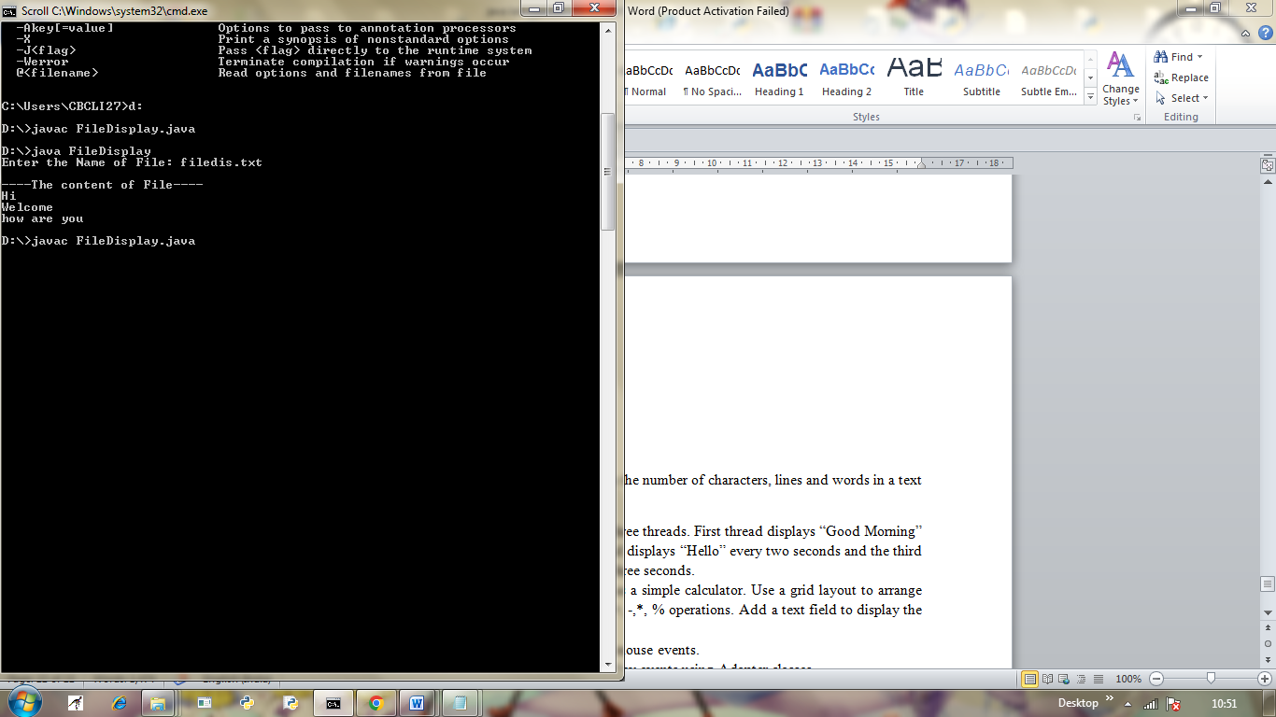

- Write a Java program that displays the number of characters, lines and words in a text file.
import java.io.*;
class FileDemo
{
public static void main(String args[])
{
try
{
int lines=0,chars=0,words=0;
int code=0;
FileInputStream fis = new FileInputStream("filedis.txt");
while(fis.available()!=0)
{
code = fis.read();
if(code!=10)
chars++;
if(code==32)
words++;
if(code==13)
{
lines++;
words++;
}
}
System.out.println("No.of characters = "+chars);
System.out.println("No.of words = "+(words+1));
System.out.println("No.of lines = "+(lines+1));
fis.close();
}
catch(FileNotFoundException e)
{
System.out.println("Cannot find the specified file...");
}
catch(IOException i)
{
System.out.println("Cannot read file...");
}
}
}
Output:
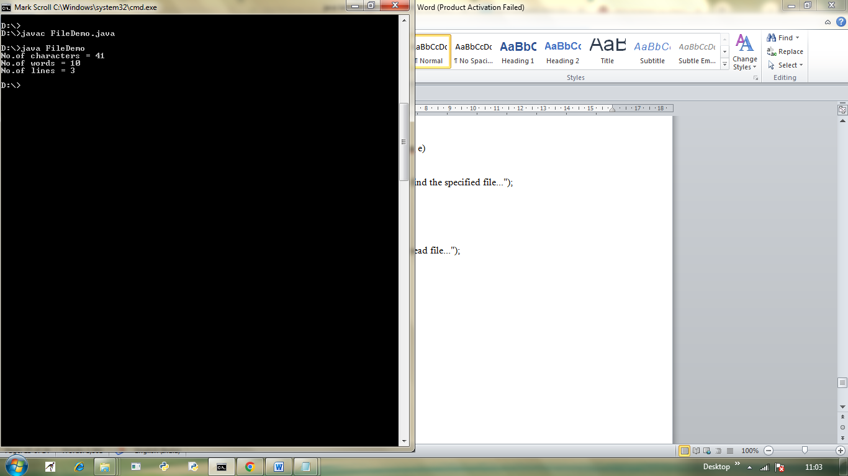
D:\>javac FileDemo.java
D:\>java FileDemo
No.of characters = 41
No.of words = 10
No.of lines = 3

- Write a Java program that creates three threads. First thread displays “Good Morning” everyone second, the second thread displays “Hello” every two seconds and the third thread displays “Welcome” every three seconds.
import java.io.*;
class One extends Thread
{
public void run()
{
for(int i=0;i<100;i++)
{
try{
Thread.sleep(1000); }
catch(InterruptedException e){
System.out.println(e); }
System.out.println("Good Morning");
}
}
}
class Two extends Thread
{
public void run()
{
for(int i=0;i<100;i++)
{
try{
Thread.sleep(2000); }
catch(InterruptedException e)
{
System.out.println(e);
}
System.out.println("Hello ");
}
}
}

class Three implements Runnable
{
public void run()
{
for(int i=0;i<100;i++)
{
try{
Thread.sleep(3000); }
catch(InterruptedException e){
System.out.println(e); }
System.out.println("Wel come");
}
}
}
class ThreadDemo
{
public static void main(String[] args)
{
One t1=new One();
Two t2=new Two();
Three tt=new Three();
Thread t3=new Thread(tt);
t1.setName("One");
t2.setName("Two");
t3.setName("Three");
System.out.println(t1);
System.out.println(t2);
System.out.println(t3);
Thread t=Thread.currentThread();
System.out.println(t);
t1.start();
t2.start();
t3.start();
}
}

D:\Lab>javac ThreadEx.java
D:\Lab>java ThreadEx
Thread[One,5,main]
Thread[Two,5,main]
Thread[Three,5,main]
Thread[main,5,main]
Good Morning
Good Morning
Hello
Wel come
Good Morning
Hello
Good Morning
Good Morning
Hello
Wel come
Good Morning
Good Morning
Hello
Good Morning

- Write a Java program that works as a simple calculator. Use a grid layout to arrange buttons for the digits and for the +, -,*, % operations. Add a text field to display the result.
import java.awt.*;
import java.awt.event.*;
import java.applet.*;
import javax.swing.*;
/*
<applet code="MyCalculator" width=300 height=300>
</applet>
*/
public class MyCalculator extends Applet implements ActionListener {
int num1,num2,result;
TextField T1;
Button NumButtons[]=new Button[10];
Button Add,Sub,Mul,Div,clear,EQ;
char Operation;
Panel nPanel,CPanel,SPanel;
public void init() {
nPanel=new Panel();
T1=new TextField(30);
nPanel.setLayout(new FlowLayout(FlowLayout.CENTER));
nPanel.add(T1);
CPanel=new Panel();
CPanel.setBackground(Color.white);
CPanel.setLayout(new GridLayout(5,5,3,3));
for(int i=0;i<10;i++) {
NumButtons[i]=new Button(""+i);
}
Add=new Button("+");
Sub=new Button("-");
Mul=new Button("*");
Div=new Button("/");
clear=new Button("clear");
EQ=new Button("=");
T1.addActionListener(this);
for(int i=0;i<10;i++) {
CPanel.add(NumButtons[i]);
}
CPanel.add(Add);
CPanel.add(Sub);
CPanel.add(Mul);
CPanel.add(Div);
CPanel.add(EQ);
SPanel=new Panel();
SPanel.setLayout(new FlowLayout(FlowLayout.CENTER));
SPanel.setBackground(Color.yellow);
SPanel.add(clear);
for(int i=0;i<10;i++) {
NumButtons[i].addActionListener(this);
}
Add.addActionListener(this);
Sub.addActionListener(this);
Mul.addActionListener(this);
Div.addActionListener(this);
clear.addActionListener(this);
EQ.addActionListener(this);
this.setLayout(new BorderLayout());
add(nPanel,BorderLayout.NORTH);
add(CPanel,BorderLayout.CENTER);
add(SPanel,BorderLayout.SOUTH);
}
public void actionPerformed(ActionEvent ae) {
String str=ae.getActionCommand ();
char ch=str.charAt(0);
if(Character.isDigit(ch))
T1.setText(T1.getText()+str);
else
if(str.equals("+")){
num1=Integer.parseInt (T1.getText());
Operation='+';
T1.setText ("");
}
if(str.equals("-")){
num1=Integer.parseInt(T1.getText());
Operation='-';
T1.setText("");
}
if(str.equals("*")){
num1=Integer.parseInt(T1.getText());
Operation='*';
T1.setText("");
}
if(str.equals("/")){
num1=Integer.parseInt(T1.getText());
Operation='/';
T1.setText("");
}
if(str.equals("%")){
num1=Integer.parseInt(T1.getText());
Operation='%';
T1.setText("");
}
if(str.equals("=")) {
num2=Integer.parseInt(T1.getText());
switch(Operation)
{
case '+':result=num1+num2;
break;
case '-':result=num1-num2;
break;
case '*':result=num1*num2;
break;
case '/':try {
result=num1/num2;
}
catch(ArithmeticException e) {
result=num2;
JOptionPane.showMessageDialog(this,"Divided by zero");
}
break;
}
T1.setText(""+result);
}
if(str.equals("clear")) {
T1.setText("");
}
}
}

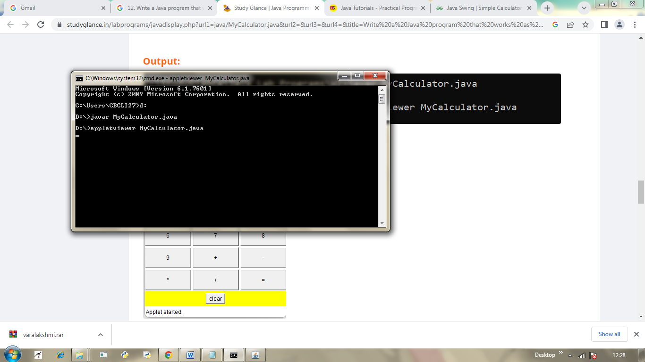
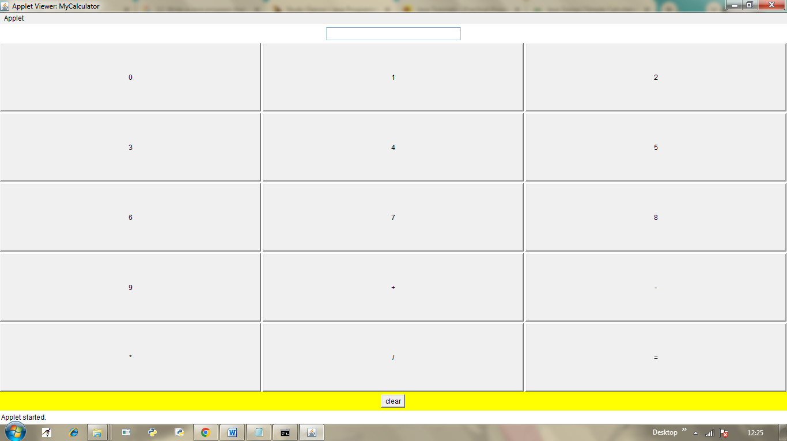
- Write a Java program for handling mouse events.
import java.awt.*;
import java.awt.event.*;
import java.applet.*;
/*<applet code="MouseEvents" width=300 height=100></applet>*/

public class MouseEvents extends Applet implements MouseListener,
MouseMotionListener,MouseWheelListener {
String msg = "";
int mouseX = 0, mouseY = 0; // coordinates of mouse

public void init() {
addMouseListener(this);
addMouseMotionListener(this);
addMouseWheelListener(this);
}

// Handle mouse clicked.
public void mouseClicked(MouseEvent me) {
// save coordinates
mouseX = 0;
mouseY = 10;
msg = "Mouse clicked.";
repaint();
}

// Handle mouse entered.
public void mouseEntered(MouseEvent me) {
// save coordinates
mouseX = 0;
mouseY = 10;
msg = "Mouse entered.";

repaint();
}
// Handle mouse exited.
public void mouseExited(MouseEvent me) {
// save coordinates
mouseX = 0;
mouseY = 10;
msg = "Mouse exited.";
repaint();
}
// Handle button pressed.
public void mousePressed(MouseEvent me) {
// save coordinates
mouseX = me.getX();
mouseY = me.getY();
msg = "Down";
repaint();
}
// Handle button released.
public void mouseReleased(MouseEvent me) {
// save coordinates
mouseX = me.getX();

mouseY = me.getY();
msg = "Up";
repaint();
}
// Handle mouse dragged.
public void mouseDragged(MouseEvent me) {
// save coordinates
mouseX = me.getX();
mouseY = me.getY();
msg = "*";
showStatus("Dragging mouse at " + mouseX + ", " + mouseY);
repaint();
}
// Handle mouse moved.
public void mouseMoved(MouseEvent me) {
// show status
showStatus("Moving mouse at " + me.getX() + ", " + me.getY());
}

// Handle mouse wheel moved.
public void mouseWheelMoved(MouseWheelEvent me) {
// show status
showStatus("Mouse Wheel Moving at " + me.getX() + ", " + me.getY());

}
// Display msg in applet window at current X,Y location.
public void paint(Graphics g) {
g.drawString(msg, mouseX, mouseY);
}
}
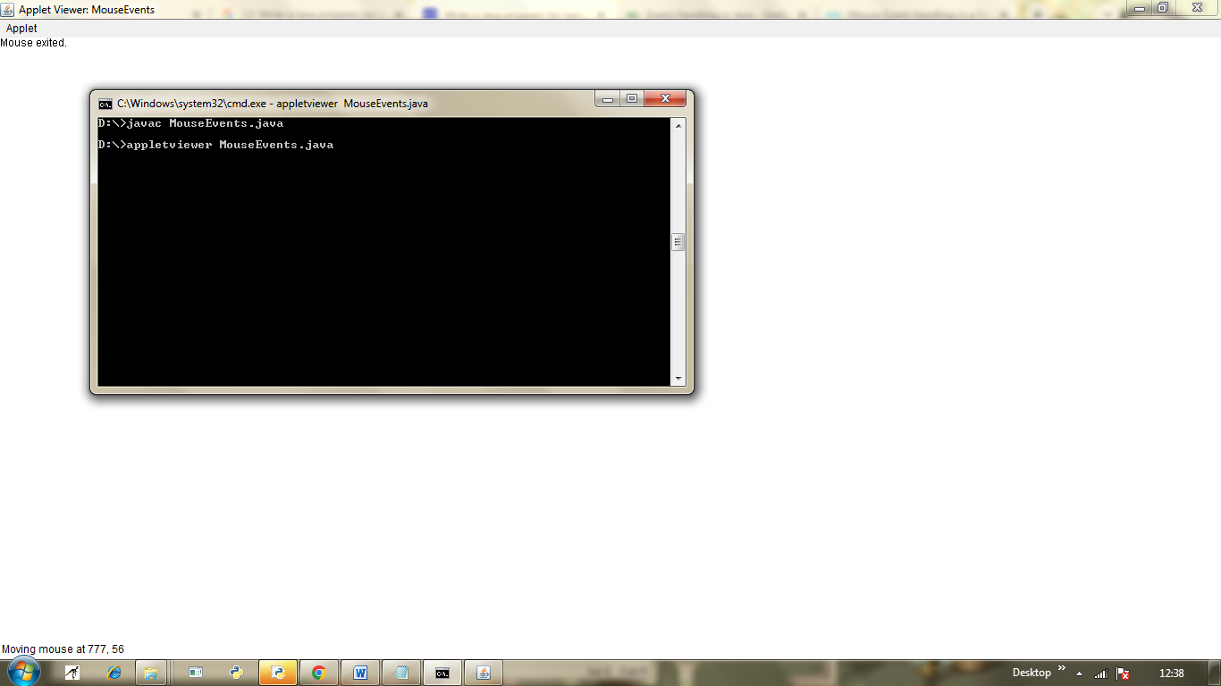
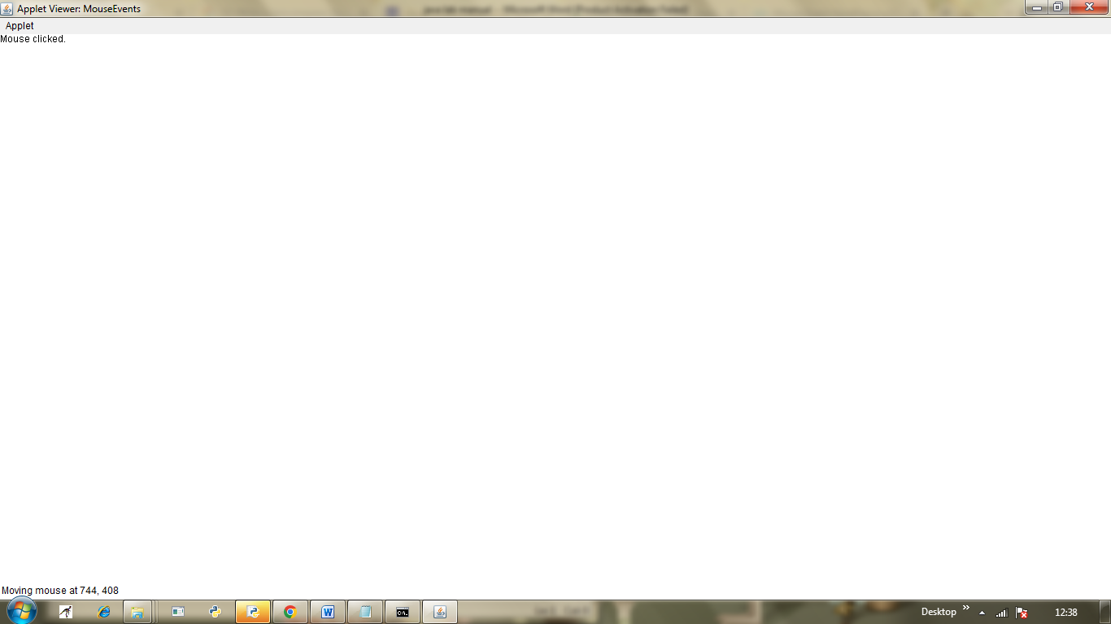
- Write a Java program for handling key events using Adapter classes

import java.awt.*;
import java.awt.event.*;
public class KeyAdapterExample extends KeyAdapter{
Label l;
TextArea area;
Frame f;
KeyAdapterExample(){
f=new Frame("Key Adapter");
l=new Label();
l.setBounds(20,50,200,20);
area=new TextArea();
area.setBounds(20,80,300, 300);
area.addKeyListener(this);

f.add(l);f.add(area);
f.setSize(400,400);
f.setLayout(null);
f.setVisible(true);
}
public void keyReleased(KeyEvent e) {
String text=area.getText();
String words[]=text.split("s");
l.setText("Words: "+words.length+" Characters:"+text.length());
}

public static void main(String[] args) {
new KeyAdapterExample();
}
}

D:\javac KeyAdapterExample.java
D:\java KeyAdapterExample
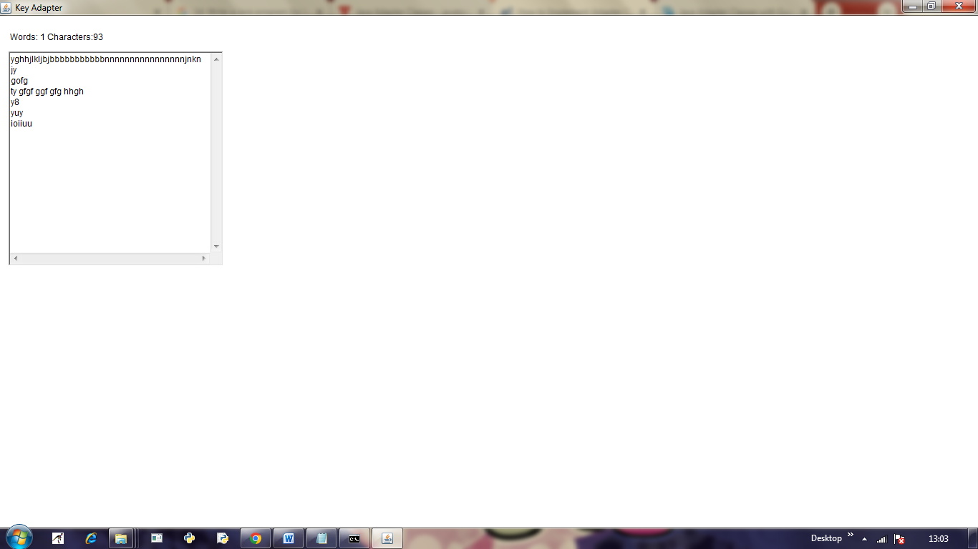
- Develop simple calculator using Swings.

. import javax.swing.*;
import java.awt.event.*;

class Calc implements ActionListener
{
JFrame f;
JTextField t;
JButton b1,b2,b3,b4,b5,b6,b7,b8,b9,b0,bdiv,bmul,bsub,badd,bdec,beq,bdel,bclr;

static double a=0,b=0,result=0;
static int operator=0;

Calc()
{
f=new JFrame("Calculator");
t=new JTextField();
b1=new JButton("1");
b2=new JButton("2");
b3=new JButton("3");
b4=new JButton("4");
b5=new JButton("5");
b6=new JButton("6");
b7=new JButton("7");
b8=new JButton("8");
b9=new JButton("9");
b0=new JButton("0");
bdiv=new JButton("/");
bmul=new JButton("*");
bsub=new JButton("-");
badd=new JButton("+");
bdec=new JButton(".");
beq=new JButton("=");
bdel=new JButton("Delete");
bclr=new JButton("Clear");
t.setBounds(30,40,280,30);
b7.setBounds(40,100,50,40);
b8.setBounds(110,100,50,40);
b9.setBounds(180,100,50,40);
bdiv.setBounds(250,100,50,40);
b4.setBounds(40,170,50,40);
b5.setBounds(110,170,50,40);
b6.setBounds(180,170,50,40);
bmul.setBounds(250,170,50,40);
b1.setBounds(40,240,50,40);
b2.setBounds(110,240,50,40);
b3.setBounds(180,240,50,40);
bsub.setBounds(250,240,50,40);
bdec.setBounds(40,310,50,40);
b0.setBounds(110,310,50,40);
beq.setBounds(180,310,50,40);
badd.setBounds(250,310,50,40);
bdel.setBounds(60,380,100,40);
bclr.setBounds(180,380,100,40);
f.add(t);
f.add(b7);
f.add(b8);
f.add(b9);
f.add(bdiv);
f.add(b4);
f.add(b5);
f.add(b6);
f.add(bmul);
f.add(b1);
f.add(b2);
f.add(b3);
f.add(bsub);
f.add(bdec);
f.add(b0);
f.add(beq);
f.add(badd);
f.add(bdel);
f.add(bclr);
f.setLayout(null);
f.setVisible(true);
f.setSize(350,500);
f.setDefaultCloseOperation(JFrame.EXIT_ON_CLOSE);
f.setResizable(false);
b1.addActionListener(this);
b2.addActionListener(this);
b3.addActionListener(this);
b4.addActionListener(this);
b5.addActionListener(this);
b6.addActionListener(this);
b7.addActionListener(this);
b8.addActionListener(this);
b9.addActionListener(this);
b0.addActionListener(this);
badd.addActionListener(this);
bdiv.addActionListener(this);
bmul.addActionListener(this);
bsub.addActionListener(this);
bdec.addActionListener(this);
beq.addActionListener(this);
bdel.addActionListener(this);
bclr.addActionListener(this);
}

public void actionPerformed(ActionEvent e)
{
if(e.getSource()==b1)
t.setText(t.getText().concat("1"));
if(e.getSource()==b2)
t.setText(t.getText().concat("2"));
if(e.getSource()==b3)
t.setText(t.getText().concat("3"));
if(e.getSource()==b4)
t.setText(t.getText().concat("4"));
if(e.getSource()==b5)
t.setText(t.getText().concat("5"));
if(e.getSource()==b6)
t.setText(t.getText().concat("6"));
if(e.getSource()==b7)
t.setText(t.getText().concat("7"));
if(e.getSource()==b8)
t.setText(t.getText().concat("8"));
if(e.getSource()==b9)
t.setText(t.getText().concat("9"));
if(e.getSource()==b0)
t.setText(t.getText().concat("0"));
if(e.getSource()==bdec)
t.setText(t.getText().concat("."));
if(e.getSource()==badd)
{
a=Double.parseDouble(t.getText());
operator=1;
t.setText("");
}
if(e.getSource()==bsub)
{
a=Double.parseDouble(t.getText());
operator=2;
t.setText("");
}
if(e.getSource()==bmul)
{
a=Double.parseDouble(t.getText());
operator=3;
t.setText("");
}
if(e.getSource()==bdiv)
{
a=Double.parseDouble(t.getText());
operator=4;
t.setText("");
}
if(e.getSource()==beq)
{
b=Double.parseDouble(t.getText());
switch(operator)
{
case 1: result=a+b;
break;
case 2: result=a-b;
break;
case 3: result=a*b;
break;
case 4: result=a/b;
break;
default: result=0;
}
t.setText(""+result);
}
if(e.getSource()==bclr)
t.setText("");
if(e.getSource()==bdel)
{
String s=t.getText();
t.setText("");
for(int i=0;i<s.length()-1;i++)
t.setText(t.getText()+s.charAt(i));
}
}

public static void main(String...s)
{
new Calc();
}
}

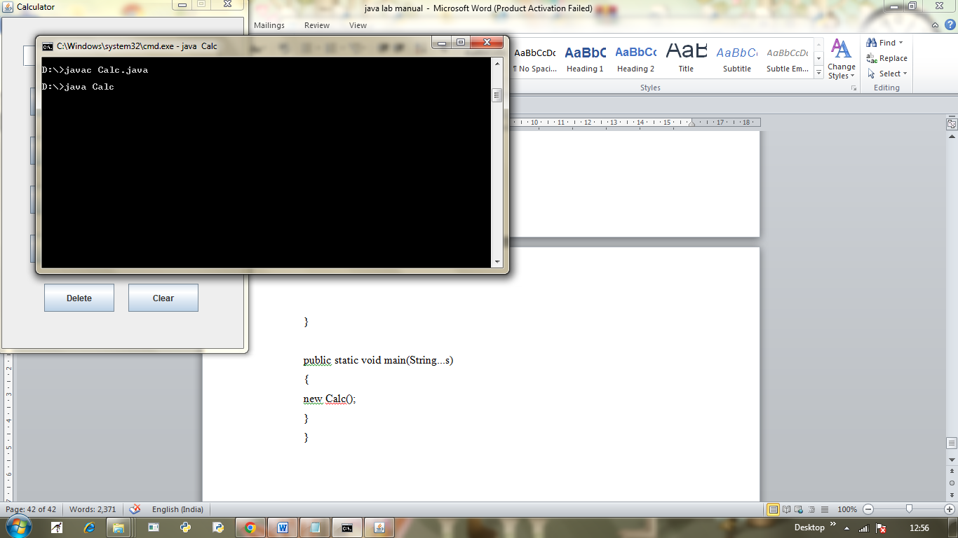

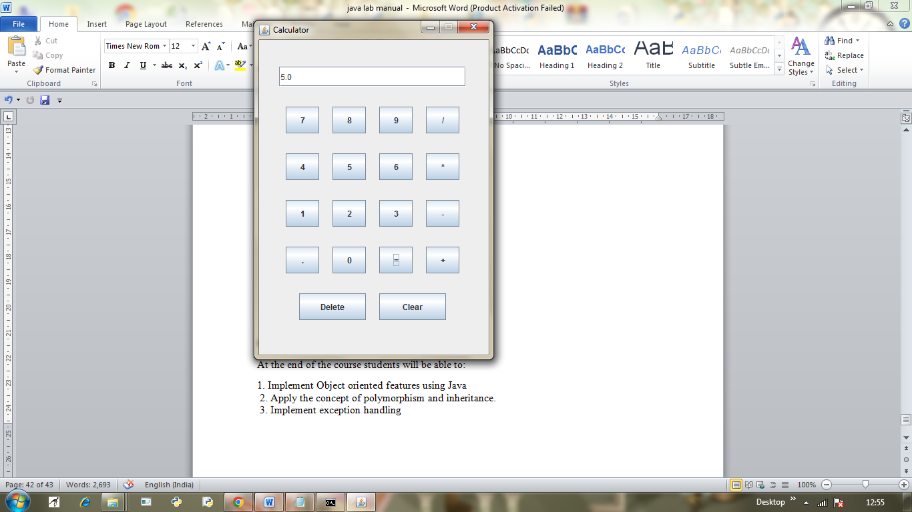
COURSE OUTCOMES:
At the end of the course students will be able to:
1. Implement Object oriented features using Java
2. Apply the concept of polymorphism and inheritance.
3. Implement exception handling
4. Develop network and window application using awt and swings.

